**LAB 2**

Recursive:

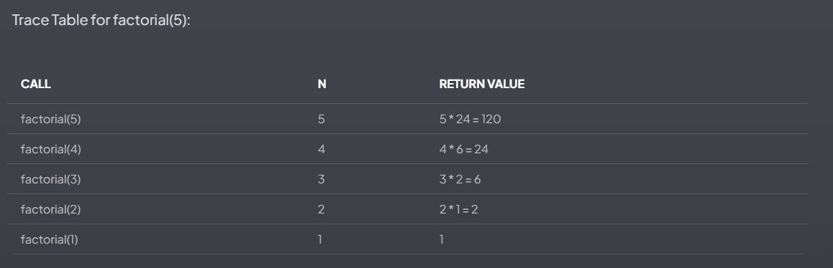

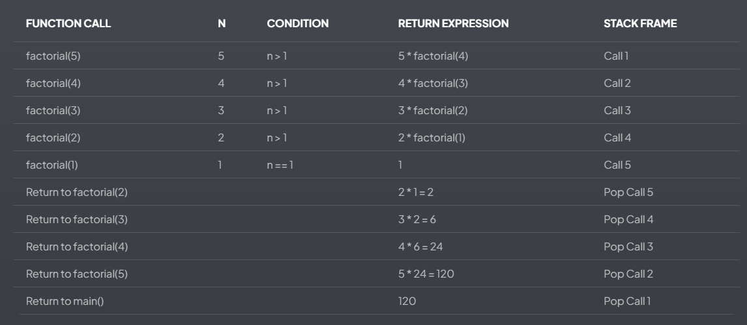

Non-recursive:

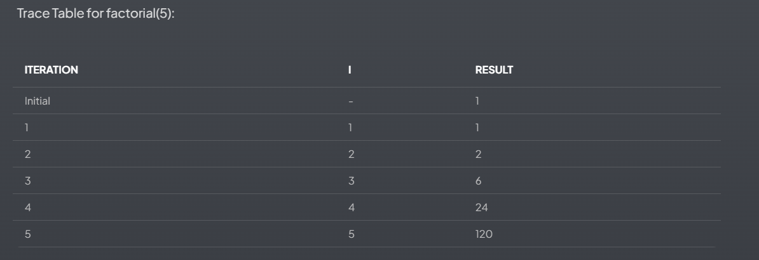

1. Recursive Approach Algorithm:

Algorithm: Recursive_Factorial(n) Input: A non-negative integer n Output: The factorial of n

1. If n is less than 0 Return an error (factorial is undefined for negative numbers)
2. If n equals 0 or 1 Return 1 (base case)
3. Otherwise Return n * Recursive_Factorial(n - 1)

Main Algorithm:

1. Start
2. Prompt user to enter a non-negative integer
3. Read input n
4. If n is negative Print error message
5. Otherwise Call Recursive_Factorial(n) Print the result
6. End
7. Non-recursive Approach Algorithm:

Algorithm: Iterative_Factorial(n) Input: A non-negative integer n Output: The factorial of n

1. If n is less than 0 Return an error (factorial is undefined for negative numbers)
2. Initialize result to 1
3. For i from 1 to n Multiply result by i
4. Return result

Main Algorithm:

1. Start
2. Prompt user to enter a non-negative integer
3. Read input n
4. If n is negative Print error message
5. Otherwise Call Iterative_Factorial(n) Print the result
6. End